**Laura Nance**

Insurance Agent

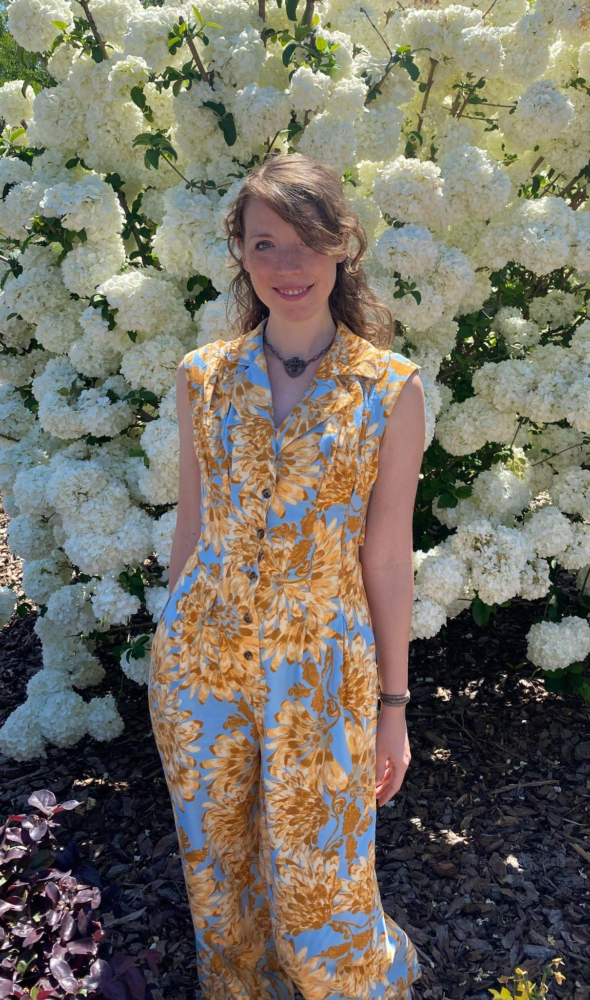

Wake Forest, NC 27587

Phone: 919-995-4011

Email: [laura.a.nance@gmail.com](mailto:laura.a.nance@gmail.com)

LinkedIn: www.linkedin.com/in/laura-nance-a144b8132/

**EXPERIENCE**

**Poshmark - Wake Forest, NC**

**Entrepreneur**

June 2022 - July 2024

* Observed market trends and developed a sales strategy.
* Worked one-on-one with customers, helping them find exactly what they needed.
* Hosted live online video auctions.
* Sold handcrafted jewelry, art, and clothing.

**Larry Sharpe for Governor - Wake Forest, NC**

**Social Media Manager**

Feb 2018 - Aug 2021

* Observed the social network trends and developed content ideas to engage target audiences and increase followers.
* Managed content creation, curation and scheduling for multiple social channels including Facebook, X, and YouTube.
* Managed daily posts across social media platforms to increase Facebook, X, and other online engagement.

**Target - Cary, NC**

**Sales Associate**

Sep 2009 - May 2010

* Greeted customers warmly and offered assistance.
* Maintained work area

**EDUCATION**

* **iianc InsurAcademy**

North Carolina

Property and Casualty Insurance (July 2024)

* **Wake Tech**

Raleigh, NC

Hotel and Restaurant Management

**CERTIFICATION AND LICENSURE**

* **NC Property and Casualty Insurance** License from State of North Carolina on August 30th, 2024

**SKILLS**

* Customer Relations
* Data analysis
* Project management
* Networking ability
* Marketing strategies
* Creative thinking
* Quality Assurance
* Entrepreneur

**SUMMARY**

A natural born leader who thrives at developing and maintaining interpersonal relationships. Excellent at observing situations and deducing the best strategies. A quick learner. Very good with people, project management, technology, and creative thinking. Currently seeking a career in the insurance industry.

**REFERENCES**

Larry Sharpe: 917-599-7285